WEEK 3 VM Deployment Documentation:
3.1 Virtual Machine Deployment
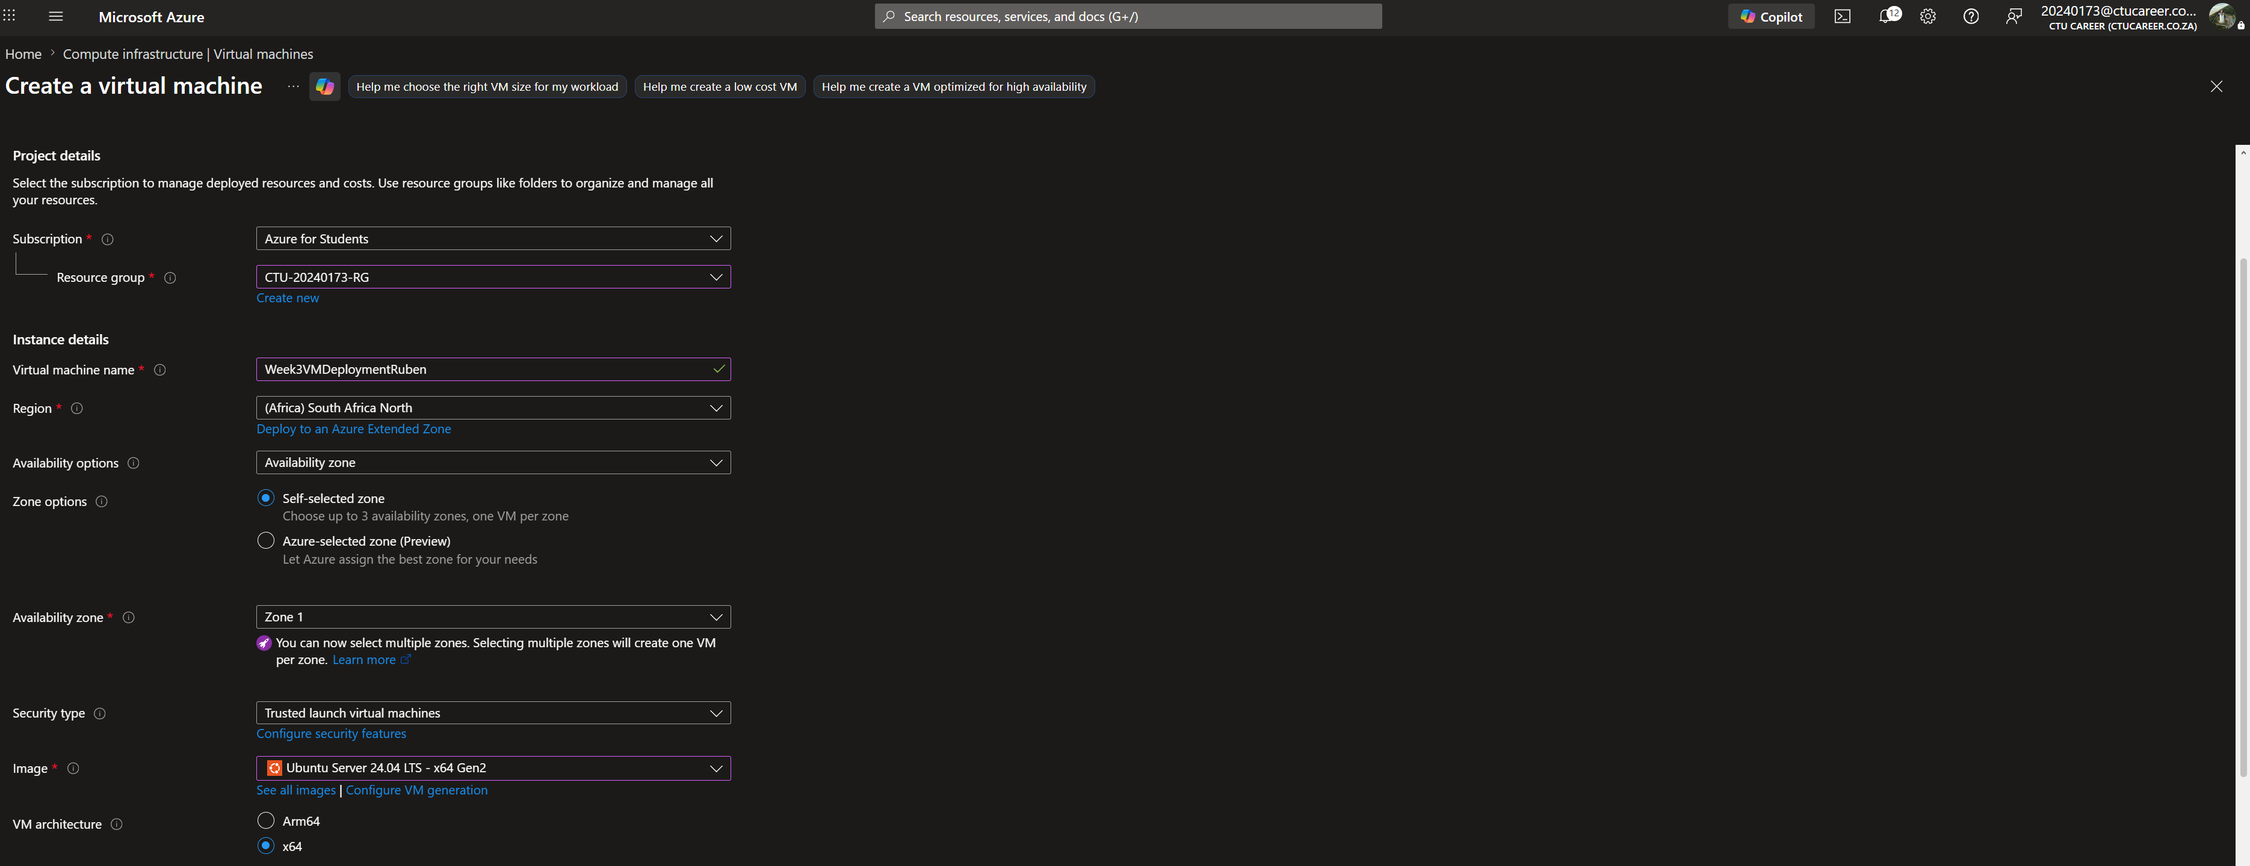

This is a standard Ubuntu Linux Deployment within the South Africa North region
3.2 Network Configuration
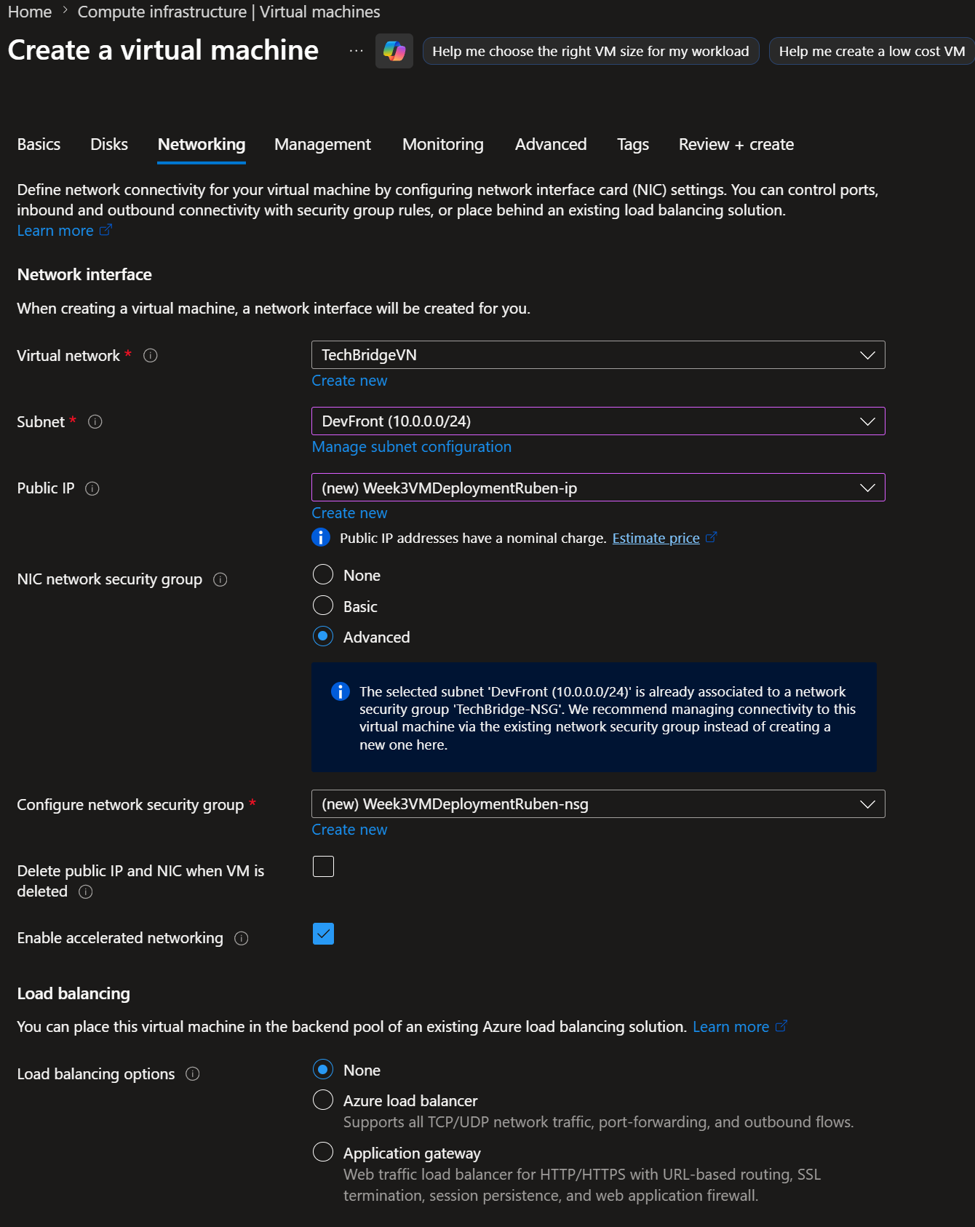

3.3 Auto-Shutdown Configuration
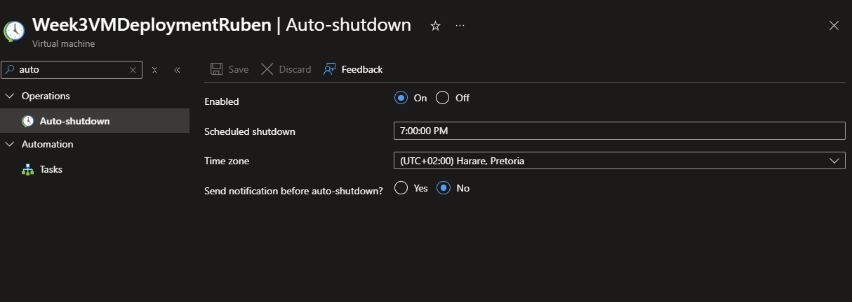
Auto shutdown configuration is at 7pm, it is a reasonable time have the VM be powered down at most workers do not work that late
3.4 Documentation

